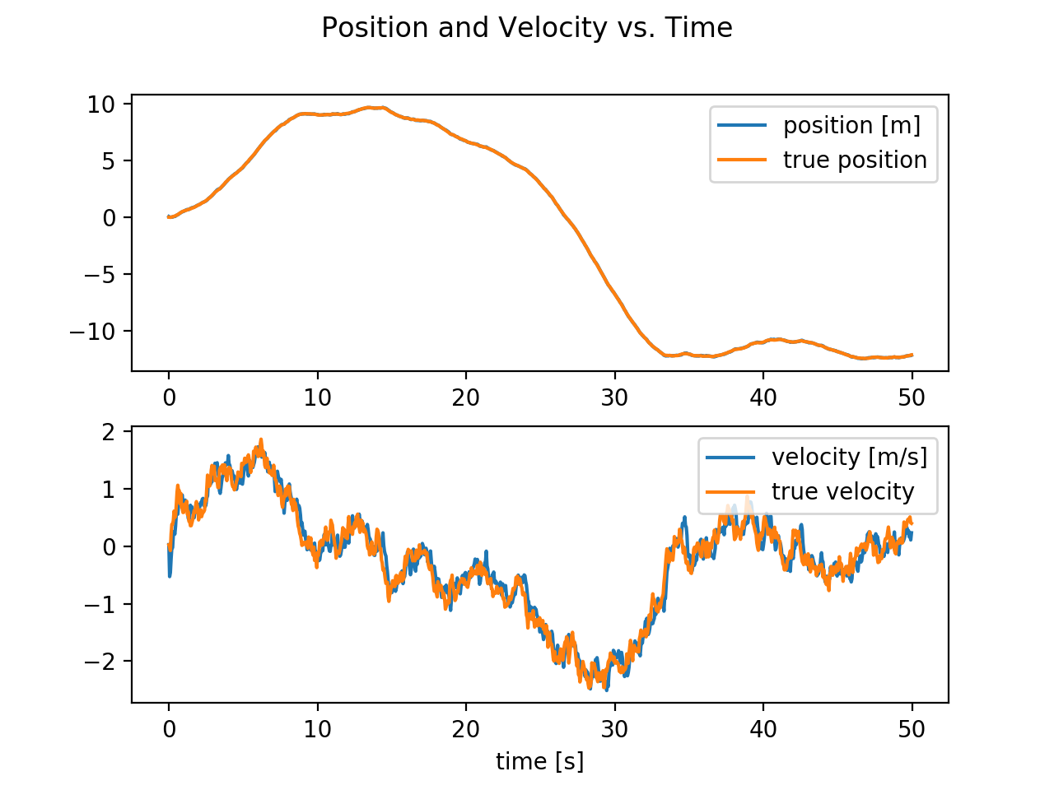

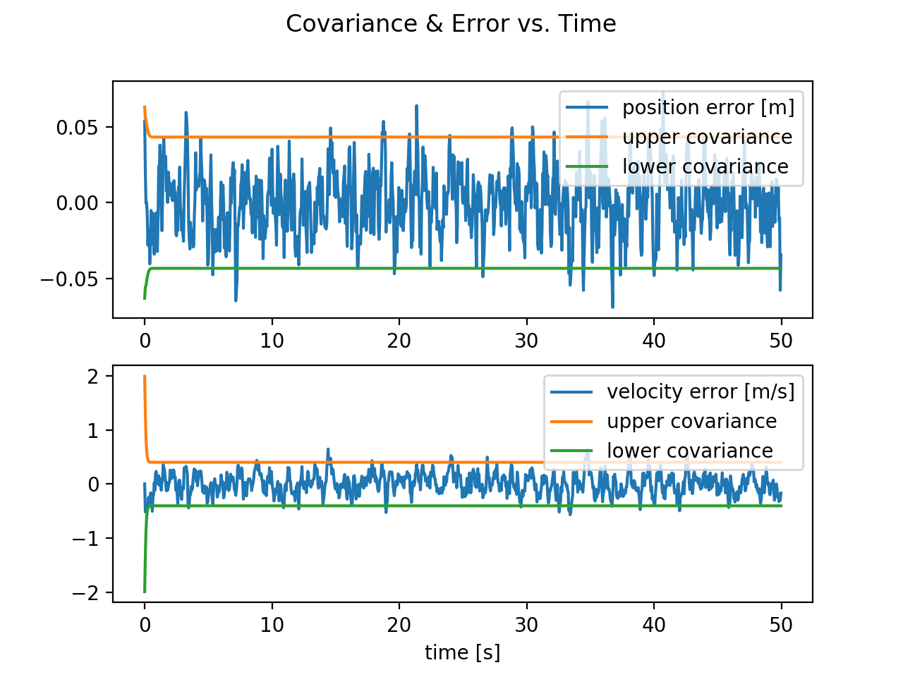

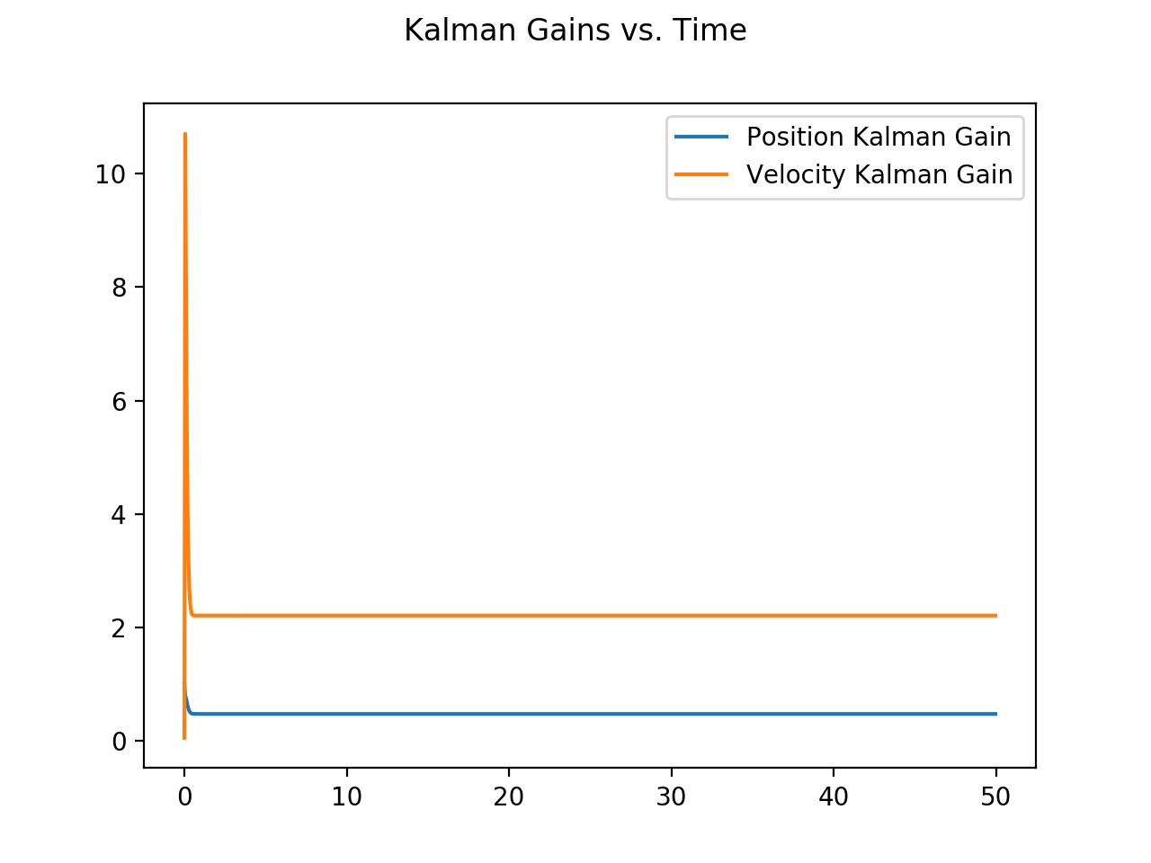

Does your estimator work as expected?

Mostly yes, but actually the position estimate does much better than I would have expected.

How does the covariance change between the prediction and measurement update?

The covariance decreases with the measurement update, because it gives you more information about the location.

Do your gains have any interesting transient characteristics? How does increasing the measurement noise affect your Kalman gains? Decreasing the measurement noise?

The gains behave dramatically as the system is locating itself early on, however, it can be seen that they soon converge to a value. As the measurement noise is increased the Kalman gain gets smaller, and as it is decreased it gets larger. This is because the Kalman gain is a sort of measure for how much confidence we have in the measurement.